1. **Write a query to display the name (first_name, last_name) and salary for all employees whose salary is not in the range $10,000 through $15,000.**

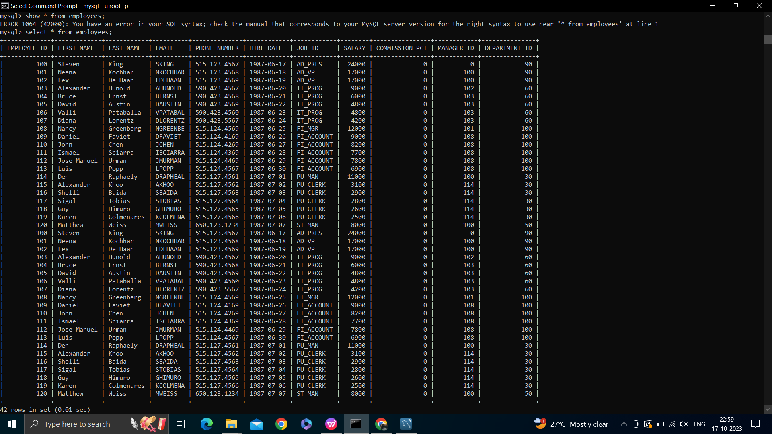

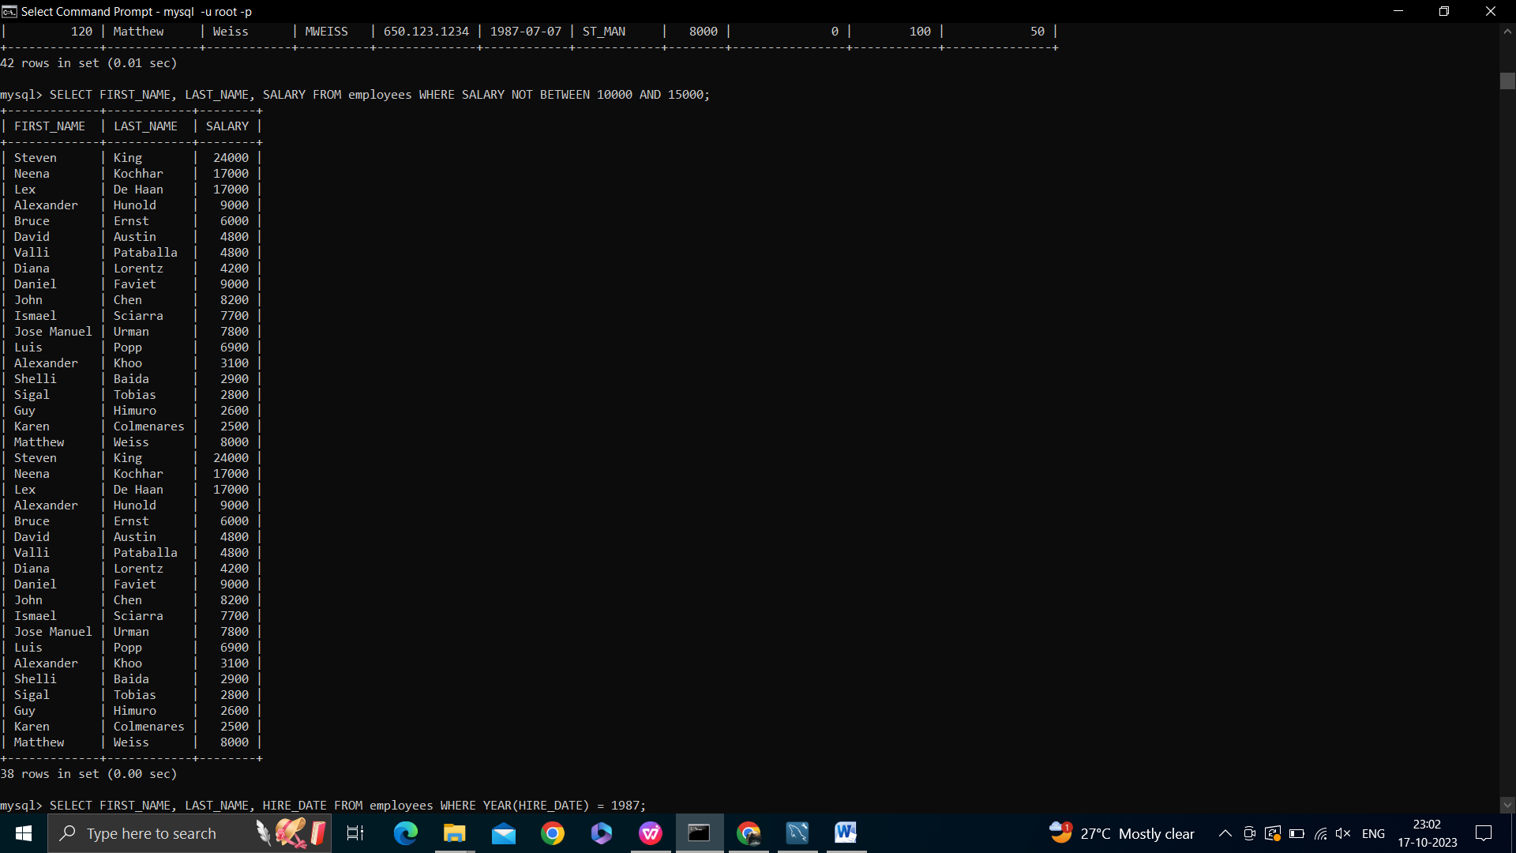

**2.Write a query to display the name (first_name, last_name) and hire date for all employees who were hired in 1987.**



**3.Write a query to list the number of jobs available in the employees table.**

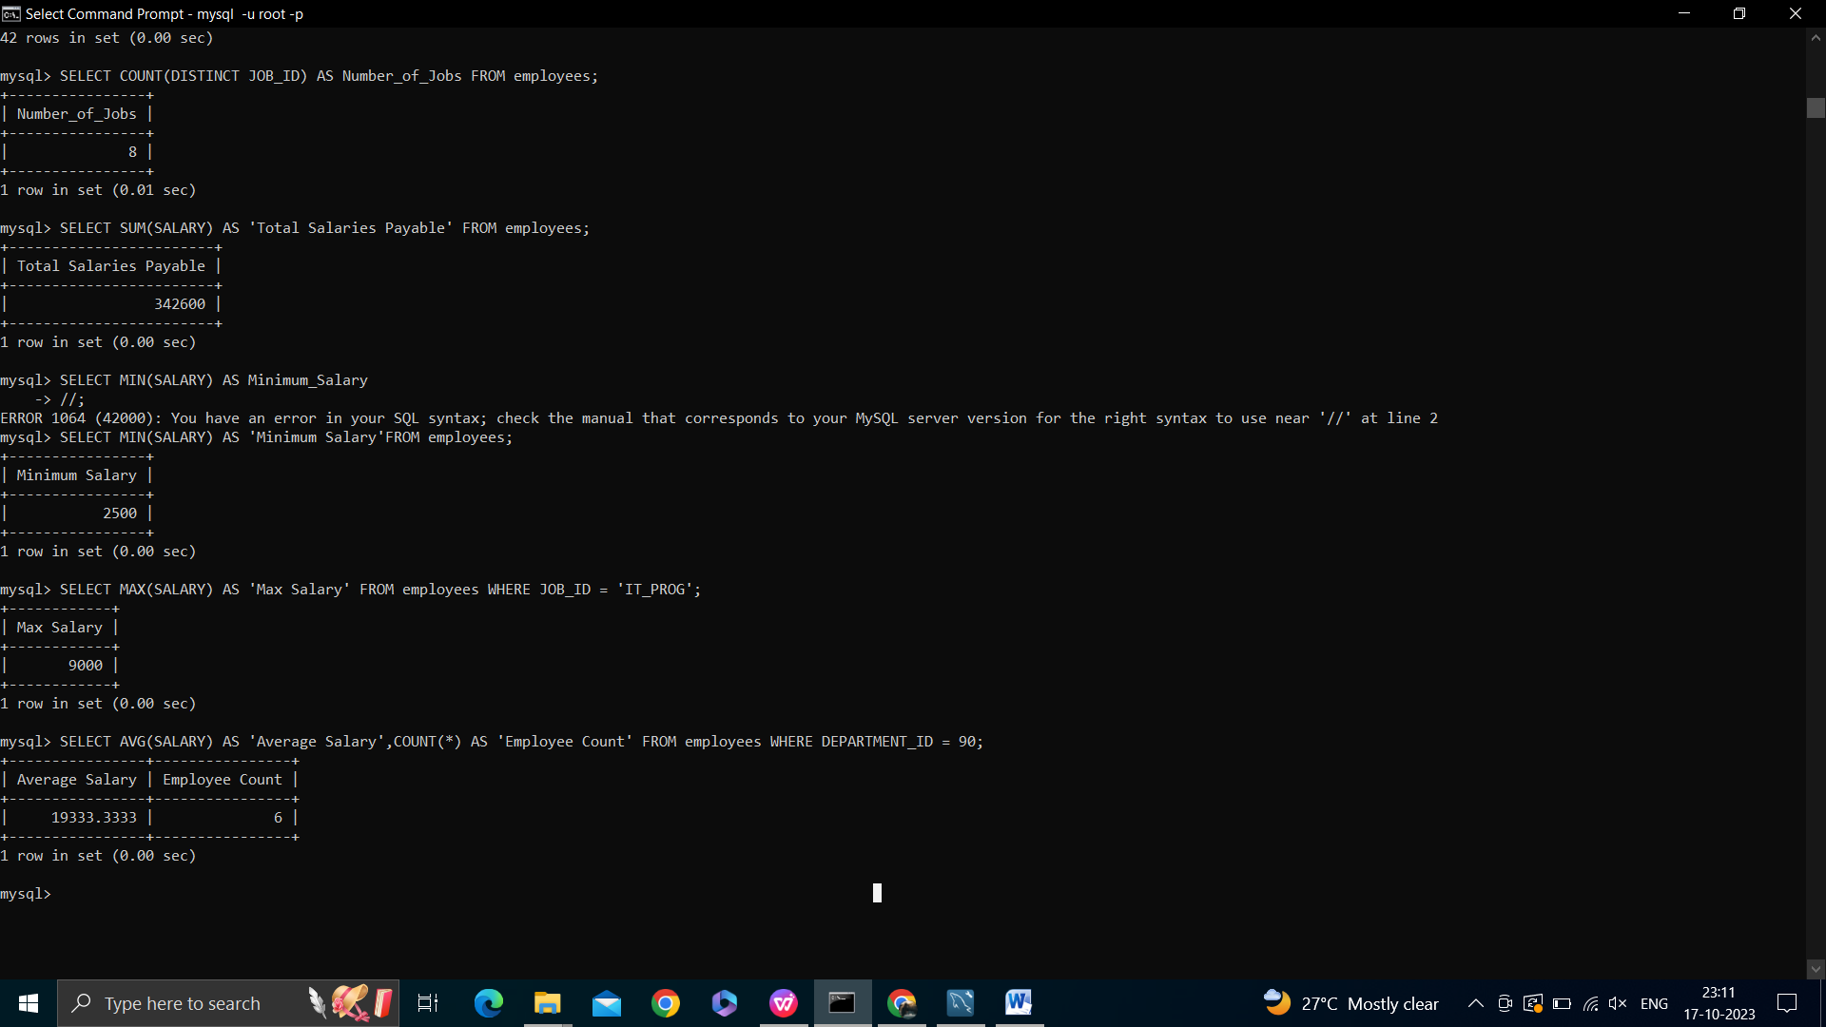

**4. Write a query to get the total salaries payable to employees.**



**5. Write a query to get the minimum salary from employees table.**



**6. Write a query to get the maximum salary of an employee working as a Programmer.**



**7. Write a query to get the average salary and number of employees working the department 90**

